1st Annual
Age- and Dementia-Friendly Winnemucca and Humboldt County
&
Humboldt Volunteer Hospice
Sprint Triathlon
When: Thursday, July 4th, 2019 – Bode Howard Pool and then around and about Winnemucca
Registration and shirt/packet pick-up 7-7:30 am
Swimming begins at 7:30
Where: Swim – Bode Howard Pool (1/3-mile)
Bike – 12-mile loop from pool to Winger’s, around neighborhoods and Offenhauser with return to pool
Run – from pool clockwise loop to Wmca Blvd, Highland, Hansen, then Haskell to pool (3-mile).
Cost: $30 single (participating in all events or just 1 or 2)
$55 team (2 or 3 members)
All proceeds will be used for Alzheimer’s Awareness, creation of the Memory Wall by the Fitness Park walkway, or Hospice.
Matching funds have been promised for the Alzheimer’s Association Longest Day

For more information and to register contact:
gini.cunningham@sbcglobal.net
www.adf-winnemucca.com
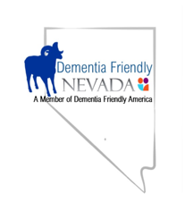
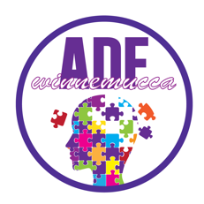
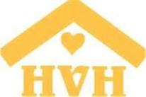

I, ______________________________, release Dementia Friendly Nevada, Humboldt Volunteer Hospice, and Age- and Dementia-Friendly Winnemucca and Humboldt County from any liability during the Sprint Triathlon to be held July 4, 2019.

I plan to participate in the (circle all that apply): swim bike ride jog/run

If you are on a team, please name the other team members and in which portion of the Sprint Triathlon each is participating: __________________; __________________

Shirt size (circle one): Small Medium Large Extra Large
Contact information (name/email/phone #):

