5th Annual Official Sprint Triathlon
Sponsored by Age- and Dementia-Friendly Winnemucca and Humboldt County
Humboldt Volunteer Hospice
Additional registration opportunities the day of the event: June 3rd
When: Saturday, June 3, 2023– Bode Howard Pool and then around and about Winnemucca
Registration and shirt/packet pick-up 6:30-7:00 am
Swimming begins at 7:00am
Where: Swim – Bode Howard Pool (1/3-mile)
Bike – 12-mile double loop from pool to Winger’s, around neighborhoods to Offenhauser, down Highland to Mizpah return to pool area for second loop
Run – from pool clockwise loop to Winnemucca Blvd, Highland, Hansen, then Haskell to pool (3.75-mile).
The swim and all routes are adaptable to meet your needs. We just want you to have fun and increase the power of your body and brain!
You can complete all 3 events solo or add a team to divide the excitement.
Cost: $30 per registrant
All proceeds will be used for Alzheimer’s Awareness Respite and Education
For more information and to register contact:
ginilc25@gmail.com
www.adf-winnemucca.com

I, ______________________________, release Dementia Friendly Nevada, Humboldt Volunteer Hospice, and Age- and Dementia-Friendly Winnemucca and Humboldt County from any liability during the Sprint Triathlon to be held September 17, 2022.

I plan to participate in the (circle all that apply): Regular Sprint Tri: swim bike run/walk
I plan to participate in the (circle all that apply): Mini-Sprint Tri: swim bike run/walk
I am (check one): __________ a serious competitor ______________ here for fun
If you are on a team, please list all team members:
Swim:
Bike:
Run:
Contact information:
Name:
Email: Phone:
Planned Routes:
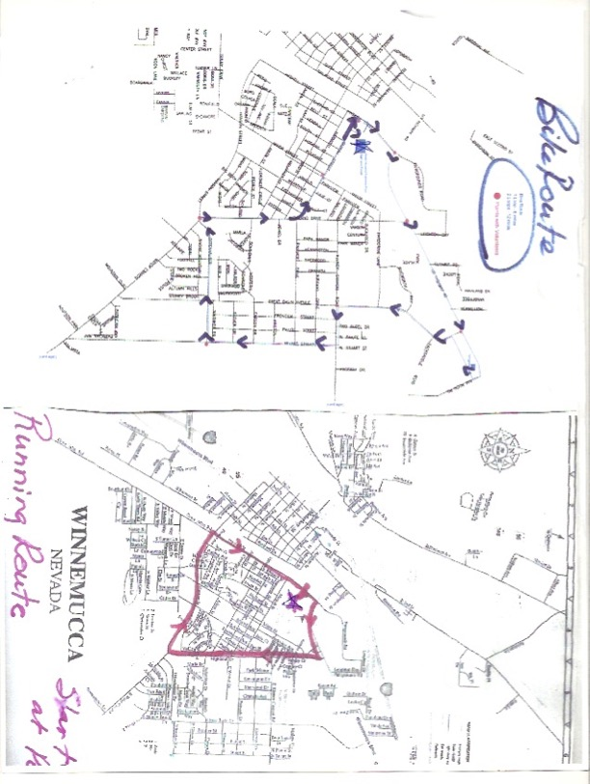

Mini-Route: TBA This course will all be near the pool area and will be supervised for younger competitors

We will launch a Sprint Tri Training Group on Saturday, March, at 8am by the pool and Vesco Park and will meet each Saturday to train and make everyone feel confident and strong. Come when you can; skip when you must.
ADF Sprint Triathlon Training Plan for June 3rd, 2023 event. Begin by March 6 but an earlier start is ideal.
12 Weeks + 1 Week Taper
 |  |  | Rest | Bike 1 | Swim 1 | Run 1 |  |  |  | Bike 2 |  | Swim 2 | Run 2
Week | Date | Phase | Monday | Tuesday | Wednesday | Thursday |  |  |  | Friday |  | Saturday | Sunday
1 | 3/6/23 | Build Up | Rest | Bike: 20 minutes | Swim: 400 yds | Run: 10 minutes |  |  |  | Bike: 20 minutes |  | Swim: 400 yds | Run: 10 minutes
2 | 3/13/23 | Build Up | Rest | Bike: 25 minutes | Swim: 600 yds | Run: 15 minutes |  |  |  | Bike: 25 minutes |  | Swim: 600 yds | Run: 15 minutes
3 | 3/20/23 | Build Up | Rest | Bike: 30 minutes | Swim: 600 yds | Run: 20 minutes |  |  |  | Bike: 30 minutes |  | Swim: 600 yds | Run: 20 minutes
4 | 3/27/23 | Endurance | Rest | Bike: 10 minutes WU  3 x [5min on, 1min off]  5 min CD | Swim: 200 WU  2 x 200 hard, 30s rest  100 CD | Run: 5 min WU  5 x [2min on, 1min off]  5 min CD |  |  |  | Bike: 40 minutes |  | Swim: 800 yds | Run: 30 minutes
5 | 4/3/23 | Endurance | Rest | Bike: 10 minutes WU  15 minutes tempo  5 min CD | Swim: 200 WU  6 x 100 hard, 30s rest  100 CD | Run: 5 min WU  6 x [2min on, 1min off]  5 min CD |  |  |  | Bike: 40 minutes |  | Swim: 900 yds | Run: 35 minutes
6 | 4/10/23 | Endurance | Rest | Bike: 10 minutes WU  3 x [5min on, 1min off]  5 min CD | Swim: 200 WU  4 x 200 hard, 30s rest  100 CD | Run: 5 min WU  7 x [2min on, 1 min off]  5 min CD |  |  |  | Bike: 45 minutes |  | Swim: 1000 yds | Run: 40 minutes
7 | 4/17/23 | Endurance | Rest | Bike: 10 minutes WU  20 minutes tempo  5 min CD | Swim: 200 WU  5 x 200 hard, 30s rest  100 CD | Run: 5 min WU  8 x [2min on, 1 min off]  5 min CD |  |  |  | Bike: 50 minutes |  | Swim: 1100 yds | Run: 45 minutes
8 | 4/24/23 | Speed | Rest | Bike: 10 minutes WU  5 x [2min uphill sprint, downhill rest]  5 min CD | Swim: 200 WU  6 x [100 moderate, 50 hard, 30s rest]  100 CD | Run: 5 min WU  10 x [45s on, 1'15" off]  5min CD |  |  |  | Bike: 10 minutes WU  30 minutes tempo  5 min CD |  | Swim: 400 yds, 30s rest  300 yds, 30s rest  200yds, 30s rest  100 yds, 30s rest | Run: 10 minutes WU  20 minutes tempo  5 min CD
9 | 5/1/23 | Speed | Rest | Bike: 10 minutes WU  6 x [2min uphill sprint, downhill rest]  5 min CD | Swim: 200 WU  6 x [100 moderate, 50 hard, 30s rest]  100 CD | Run: 5 min WU  10 x [45s on, 1'15" off]  5min CD |  |  |  | Bike: 10 minutes WU  30 minutes tempo  5 min CD |  | Swim: 400 yds, 30s rest  300 yds, 30s rest  200yds, 30s rest  100 yds, 30s rest | Run: 10 minutes WU  25 minutes tempo  5 min CD
10 | 5/8/23 | Speed | Rest | Bike: 10 minutes WU  12 x [1min sprint, 1min rest]  5 min CD | Swim: 200 WU  8 x [100 hard, 30s rest]  100 CD | Run: 5 min WU  8 x [45s on, 1'15" off]  4 x [30s on, 30s off]  5min CD |  |  |  | Bike: 10 minutes WU  35 minutes tempo  5 min CD |  | Swim: 600 yds, 30s rest  400 yds, 30s rest  200yds, 30s rest | Run: 10 minutes WU  20 minutes tempo  4-6 x 20s strides  5 min CD
11 | 5/15/23 | Maintain | Rest | Bike: 10 minutes WU  5min on, 1 min off  4min on, 1min off  3min on, 1 min off  2min on, 1 min off  1min on, 1 min off  5 min CD | Swim: 400 WU  4 x [100 hard, 30s rest]  100 CD | Run: 5 min WU  10 minutes steady  4 x [2min on, 1 min off]  5 min CD |  |  |  | Bike: 10 min WU  20 minutes steady  5 minutes hard  5 min CD |  | Swim: 800 yds  2 x [100 hard, 30s rest]  100 CD | Run: 35-45 minutes
12 | 5/22/23 | Maintain | Rest | Bike: 10 minutes WU  5min on, 1 min off  4min on, 1min off  3min on, 1 min off  2min on, 1 min off  1min on, 1 min off  5 min CD | Swim: 600 yds  4 x [100 hard, 30s rest]  100 CD | Run: 5 min WU  10 minutes steady  6 x [1min on, 1 min off]  5 min CD |  |  |  | Bike: 10 min WU  20 minutes steady  5 minutes hard  5 min CD |  | Swim: 800 yds  4 x [50 hard, 20s rest]  100 CD | Run: 40-50 minutes
Race Week | 5/29/23 | Taper | Rest | Bike: 10 minutes WU  10 minutes Tempo  10 minutes CD | Swim: 200 WU  600 yds  100 CD | Run: 5 min WU  10 min tempo  5 min CD |  |  |  | Rest or very light workout of your choice |  | ADF Sprint Triathlon! | Rest

 |  |  |  | Rest | Bike 1 |  |  |  |  | Swim 1 |  | Run 1 |  |  | Bike 2 |  |  | Swim 2 |  |  | Run 2
Date | Phase |  |  | Mon-day | Tuesday |  |  |  |  | Wednesday |  | Thursday |  |  | Friday |  |  | Saturday |  |  | Sunday
6/20/22 | Build Up |  |  | Rest | Bike: 20 minutes |  |  |  |  | Swim: 400 yds |  | Run: 10 minutes |  |  | Bike: 20 minutes |  |  | Swim: 400 yds |  |  | Run: 10 min-  utes
6/27/22 | Build Up |  |  | Rest | Bike: 25 minutes |  |  |  |  | Swim: 600 yds |  | Run: 15 minutes |  |  | Bike: 25 minutes |  |  | Swim: 600 yds |  |  | Run: 15 min-  utes
7/4/22 | Build Up |  |  | Rest | Bike: 30 minutes |  |  |  |  | Swim: 600 yds |  | Run: 20 minutes |  |  | Bike: 30 minutes |  |  | Swim: 600 yds |  |  | Run: 20 min-  utes
7/11/22 | Endurance |  |  | Rest | Bike: 10 minutes WU  3 x [5min on, 1min off]  5 min CD |  |  |  |  | Swim: 200 WU  2 x 200 hard, 30s rest  100 CD |  | Run: 5 min WU  5 x [2min on, 1min off]  5 min CD |  |  | Bike: 40 minutes |  |  | Swim: 800 yds |  |  | Run: 30 min-  utes
7/18/22 | Endurance |  |  | Rest | Bike: 10 minutes WU  15 minutes tempo  5 min CD |  |  |  |  | Swim: 200 WU  6 x 100 hard, 30s rest  100 CD |  | Run: 5 min WU  6 x [2min on, 1min off]  5 min CD |  |  | Bike: 40 minutes |  |  | Swim: 900 yds |  |  | Run: 35 min-  utes
7/25/22 | Endurance |  |  | Rest | Bike: 10 minutes WU  3 x [5min on, 1min off]  5 min CD |  |  |  |  | Swim: 200 WU  4 x 200 hard, 30s rest  100 CD |  | Run: 5 min WU  7 x [2min on, 1 min off]  5 min CD |  |  | Bike: 45 minutes |  |  | Swim: 1000 yds |  |  | Run: 40 min-  utes
8/1/22 | Endurance |  |  | Rest | Bike: 10 minutes WU  20 minutes tempo  5 min CD |  |  |  |  | Swim: 200 WU  5 x 200 hard, 30s rest  100 CD |  | Run: 5 min WU  8 x [2min on, 1 min off]  5 min CD |  |  | Bike: 50 minutes |  |  | Swim: 1100 yds |  |  | Run: 45 min-  utes
8/8/22 | Speed |  |  | Rest | Bike: 10 minutes WU  5 x [2min uphill sprint, downhill rest]  5 min CD |  |  |  |  | Swim: 200 WU  6 x [100 moderate, 50 hard, 30s rest]  100 CD |  | Run: 5 min WU  10 x [45s on, 1'15" off]  5min CD |  |  | Bike: 10 minutes WU  30 minutes tempo  5 min CD |  |  | Swim: 400 yds, 30s rest  300 yds, 30s rest  200yds, 30s rest  100 yds, 30s rest |  |  | Run: 10 min-  utes WU  20 minutes  tempo  5 min CD
8/15/22 | Speed |  |  | Rest | Bike: 10 minutes WU  6 x [2min uphill sprint, downhill rest]  5 min CD |  |  |  |  | Swim: 200 WU  6 x [100 moderate, 50 hard, 30s rest]  100 CD |  | Run: 5 min WU  10 x [45s on, 1'15" off]  5min CD |  |  | Bike: 10 minutes WU  30 minutes tempo  5 min CD |  |  | Swim: 400 yds, 30s rest  300 yds, 30s rest  200yds, 30s rest  100 yds, 30s rest |  |  | Run: 10 min-  utes WU  25 minutes  tempo  5 min CD
8/22/22 | Speed |  |  | Rest | Bike: 10 minutes WU  12 x [1min sprint, 1min rest]  5 min CD |  |  |  |  | Swim: 200 WU  8 x [100 hard, 30s rest]  100 CD |  | Run: 5 min WU  8 x [45s on, 1'15" off]  4 x [30s on, 30s off]  5min CD |  |  | Bike: 10 minutes WU  35 minutes tempo  5 min CD |  |  | Swim: 600 yds, 30s rest  400 yds, 30s rest  200yds, 30s rest |  |  | Run: 10 min-  utes WU  20 minutes  tempo  4-6 x 20s  strides  5 min CD
8/29/22 | Maintain |  |  | Rest | Bike: 10 minutes WU  5min on, 1 min off  4min on, 1min off  3min on, 1 min off  2min on, 1 min off  1min on, 1 min off  5 min CD |  |  |  |  | Swim: 400 WU  4 x [100 hard, 30s rest]  100 CD |  | Run: 5 min WU  10 minutes steady  4 x [2min on, 1 min off]  5 min CD |  |  | Bike: 10 min WU  20 minutes steady  5 minutes hard  5 min CD |  |  | Swim: 800 yds  2 x [100 hard, 30s rest]  100 CD |  |  | Run: 35-45  minutes
9/5/22 | Maintain |  |  | Rest | Bike: 10 minutes WU  5min on, 1 min off  4min on, 1min off  3min on, 1 min off  2min on, 1 min off  1min on, 1 min off  5 min CD |  |  |  |  | Swim: 600 yds  4 x [100 hard, 30s rest]  100 CD |  | Run: 5 min WU  10 minutes steady  6 x [1min on, 1 min off]  5 min CD |  |  | Bike: 10 min WU  20 minutes steady  5 minutes hard  5 min CD |  |  | Swim: 800 yds  4 x [50 hard, 20s rest]  100 CD |  |  | Run: 40-50  minutes
9/12/22 | Taper |  |  | Rest | Bike: 10 minutes WU  10 minutes Tempo  10 minutes CD |  |  |  |  | Swim: 200 WU  600 yds  100 CD |  | Run: 5 min WU  10 min tempo  5 min CD |  |  | Rest or very light workout of your choice |  |  | ADF Sprint Triathlon! |  |  | Rest

WU – warm up
CD – cool down

