Registration:
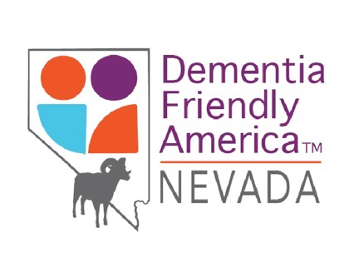
First Annual ADF-Winnemucca
and Humboldt County
Brain Health Conference
Health and Wellness with Your Brain
(and Its Future) in Mind
Friday, September 17th, 2021
8am-5pm
Live: Boys and Girls Club – Winnemucca Nevada
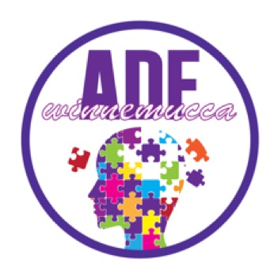
Virtual Attendance: via ZOOM
Following CDC and Nevada
Mask and Distancing Recommendations

Name:

Email Address:

Phone:

Organization:

Return this form to: ginilc25@gmail.com

